Parramatta Diocese
Catholic Education Office

2001 HSC
Half Yearly Paper

Mathematics

Extension 1

* Schools will need to supplement this material with
work relevant to their teaching programs.

2001
HIGHER SCHOOL CETIFICATE
HALF YEARLY EXAMINATION

Mathematics

Extension 1

General Instructions  - Reading time – 5 minutes  - Working time – 2 hours  - Write using blue or black pen  - Board –approved calculators may be used.  - A table of standard integrals is provided  - All necessary working should be shown in every question. | Total marks (45)  - Attempt Questions 1- 4

Section I

Total marks (48)
Attempt all parts of Questions 1 - 4

Answer the question in a SEPARATE writing booklet. Extra writing booklets are available.
____________________________________________

Question 1 (12 marks) Use a SEPARATE writing booklet Marks

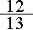
(a) If sin A = , 90º < A <180º and COS B = , 0º < B < 90º,
find the value of

i) cos 2A 2

ii) tan (A + B) 2

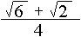
(b) Using the expansion of sin (A + B) prove that sin 75º = 2

(c)
i) Show the statement sin x = on a diagram 1

ii) Show that 1 + sin x + cos x =
1 + sin x – cos x 2

- Find the acute angle between the line 3y – 2x =7 and the line joining the points
(1, 4) and (-1, 12) 3

(Answer to the nearest minute)

Question 2 (9 marks) Use a SEPARATE writing booklet.

- Solve the following inequality

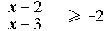
4

- i) Given A (-4, 6) and B (2, 8)

Find the coordinates of the point that divides the interval AB externally in
the ratio 3:2 2

- In what ratio does the point P (-2, 3) divide the interval AB where A is (-5,6)
and B is (4, -3) ? 3

Question 3 (12 marks) Use a SEPARATE writing booklet Marks

- MATHEX TRANSPORT COMPANY pays its truck drivers $20 an hour plus
petrol costs of 95c per litre. A driver’s next delivery is 200 km away. If he
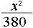
drives at a constant speed of x km / hour and consumes petrol at the rate of
( 10 + ) litres per hour.

- Show that the total cost to MATHEX for this trip is given by

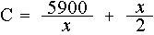
2

- What is the most economical speed (to the nearest km/hour) and the cost of the
trip (to the nearest cent)? 3

iii) If trucks are speed limited to 100km / hour what effect, if any, would this have
on the cost of the trip? Justify your answer. 1

(b)
- Evaluate

(3x² + 4x + 2) dx 1

- Find the primitive function of :

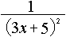
2

iii) The part of the curve y = 2^{x} for 0 ≤ x ≤ 2 is rotated about the x-axis.

Use Simpson’s Rule with 3-function values to evaluate the volume so
formed (your answer in exact values). 3

(c) If , , and , are the roots of the equation x³ + 3x² - 2x + 6 = 0, find the
value of

- 1
- 2

Question 4 (12 marks) Use a SEPARATE writing booklet

- Use the method of mathematical induction to show that 3^{n} > 2n + 4 for all
positive integers n ≥ 2. 4

(b)
i) Show that the x coordinates of the points of intersection of the curves xy = -3
and y = x² − 3x satisfy the equation

P(x) = 0 where P(x) = x³ – 3x² + 3. 1

ii) Show that the equation P(x) = 0 has a solution x = where 1 < < 2. 2

iii) Use one application of halving the interval method to find the value of
correct to the nearest whole number. 1

iv) Use Newton’s Method to show that if x = a is an initial approximation to
the value of then the next approximation is given by
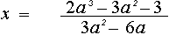
1

v) Use two applications of Newton’s Method starting with an initial
approximation of x = 1 to find a better approximation to the value of ,
giving the answer correct to two decimal places. 2

vi) Explain why an initial approximation of x = 2 is not suitable using
Newton’s method. 1

Parramatta Diocese
Catholic Education Office

2001 HSC
Marking Guidelines

Mathematics

MARKING GUIDELINES

Question 1 (a)

Outcome Assessed: PE2, PE6

Criteria | Marks
- Correct substitution of values from the sketches  - Solution for each sub-question | 4

Sample Answer:

a) Sin A = , 90º <A <180º COS B = 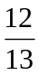, 0º < B < 90º

5 13
3 5
A B
-4 o o 12

Cos A = - 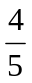 Sin B = 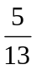

Tan A = - 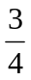 tan B = 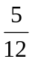

i) Cos 2A = cos² A – sin² A

= 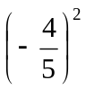- 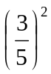

= 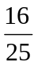 - 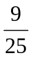 = 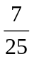

b) tan (A+B) = Tan A + tan B

1 – tan A tan B

= 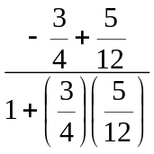 = 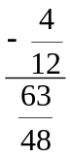 = 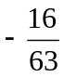

Question 1 (b)

Outcome Assessed: PE2, PE6

Criteria | Marks
- Showing the expansion  - Simplifying and rationalizing | 2

Sample Answer:

LHS : Sin 75º = sin (30º + 45º)

= sin 30º sin 45º + cos 30º cos 45º

= 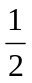• 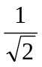 + 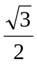 •

= 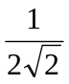 + 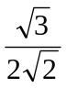

= 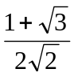 X 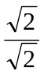

= 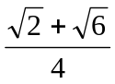

= RHS

Question 1 (c)

Outcome Assessed: PE2, PE6

Criteria | Marks
- Sketch with sides labelled | 1
- Correctly substitutes the value of sin x and cos x from the sketch  - Correctly proves RHS = from the substituion | 2

Sample Answer:

(i)
Use Pythagoras to find the third side 1
1+t²
2t

1 –t²

- LHS = 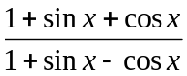

= 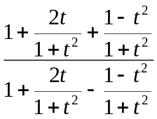 • 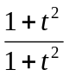

= 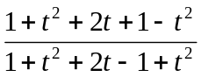

= = RHS

Question 1 (d)

Outcome Assessed: PE2, PE6

Criteria | Marks
- Finding the equation of the line joining the points (1,4) and (-1, 12)  - Correctly substituting the value of m in the formula  - Correctly giving the solution of θ | 3

Sample Answer:

Equation of the line joining (1,4) and (-1, 12)

Y₁ - y2 = m (x – x1)

y – 4 = 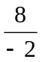 (x – 1)

y – 4 = -4x +4

y = -4x + 8

Angle between 3y – 2x = 7 and y = -4x +8

m₁ = -4

m₂ = 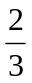

∴ tan θ = 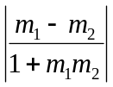

= 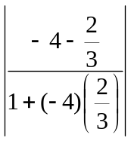 = 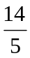

∴ θ = 70 º 21′ 3

Question 2 (a)

Outcome Assessed: PE3

Criteria | Marks
- One mark for step 1 | 1
- One mark for collecting like terms and factorising | 1
- One mark for each value students have to indicate that x ≠ -3 or 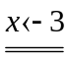 | 2

Sample Answer:

a) Since (x +3)² > 0 ∴ Multiply will not change inequality 1

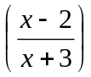 ( x + 3)² ≥ -2 (x + 3)²

(x – 2) (x + 3) ≥ -2(x ² + 6x + 9)

x² + x – 6 ≥ -2x² - 12x – 18

3x² + 13x + 12 ≥ 0

(3x + 4) (x + 3) ≥ 0 1

∴ 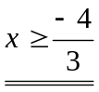 1

• •
-3 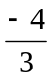

1

Question 2 (b)

Outcome Assessed: PE2, PE6

Criteria | Marks
- One mark for correct ratio | 1
- One mark for answer | 1

Sample Answer:
i) (-4, 6) (2,8) m, = 3 p(x,y)
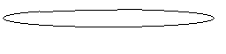 x₁, y₁ x₂, y₂ • •

A(-4,6) •

B(2,8) m2 = -2

M₁ = 3
M₂ = -2

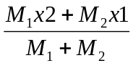, 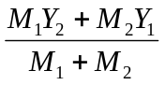

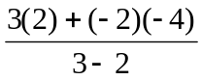, 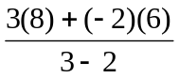

(14,12) 2

Question 2 (b)

Outcome Assessed: PE2, PE6

Criteria | Marks
- One mark for correct distance A P | 1
- One mark for correct distance PB | 1
- One mark for correct simplified ratio AP:PB | 1

Sample Answer:

ii)
A (-5, 6)
• 6

P(-2, 3) •

4
-5
• B (4, -3)
-3

distance AP = 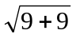

= 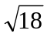

= 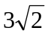

distance PB = 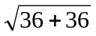

= 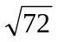

= 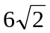

∴ :

1:2

Question 3 (a)

Outcome Assessed: H4 and H5

Criteria | Marks
(i)  - Finding time, amount of petrol used, cost of petrol, total cost.  - Finding any one of above correctly or using an incorrect answer with correct procedure. | 2  1
(ii)  - Finding C¹ correctly and putting C¹ = 0 …….  Note: No mark awarded for correct x value but attained x value must be  used correctly to  - test second derivative …………………….  - find the cost ……………………. | 1  1  1
(iii)  - Finding the cost using x = 100 and / or making a valid statement supported with evidence. | 1

Sample Answer:

i) Time = 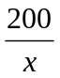hours

Amount of petrol used = 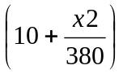

= 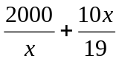 litres

Cost of Petrol = 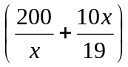 • 95

= 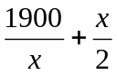

∴ Total cost = 20 x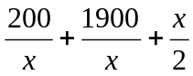

= 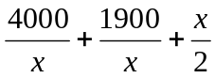

c = 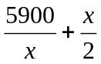

ii) For minimum cost c′ = 0, c″ >0

c = 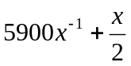

c′ = 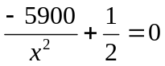
x² = 11800

∴ x ≈ ± 108.63

≈ 109km/hour

c″ = 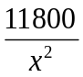

When x = 109 c″ > 0 ∴ minimum
When x = 109

c″ = 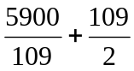

≈ $108.63

- If trucks are speed limited to 100km/hour then the minimum cost will be

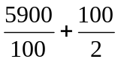

= $109

- Limiting the truck to 100km/hour will only cost the company 37c
more - not a huge loss for this trip.

Question 3 (b)

Outcome Assessed: H5, H8

Criteria | Marks
(i)  - One mark for correct answer | 1
(ii)  - One mark for realising 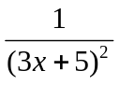 = (3x + 5)⁻²  - One mark for correct answer | 1  1
(iii)  - One mark for value of ‘h’  - One mark for correct substitution  - One mark for correct answer. | 1  1  1

Sample Answer:

- 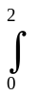(3x² + 4x + 2) . dx

= [ x³ + 2x² + 2 ]

= ( 8 + 8 + 2 ) – ( 0 )

= 18

ii) f(x) = 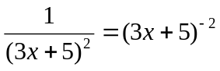

f(x) = 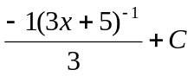

= 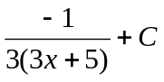

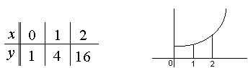
iii)

V = π y² . dx

= π 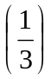 ( 1 + 16 + 4 (4) )

= 11 π units³

Question 3 (c)

Outcome Assessed: PE3

Criteria | Marks
(i)  - One mark for correct answer to sum of roots one at a time and sum of roots two at a time | 1
(ii)  - One mark for correct formula  - One mark for correct substitution using data from 3 c i) | 1  1

Sample Answer:

i) 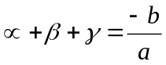 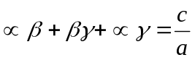

= 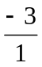 = 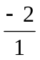

= -3 = -2

ii)

= (-3)² – 2 (-2)

= 9 + 4

= 13

Question 4 (a)

Outcome Assessed: HE2

Criteria | Marks
- Showing S(2) true  - Starting with 3^{k} > 2k + 4 and showing 3^{k + 1} > 6k + 12  - Continuing from 3^{k + 1} > 6k + 12 to show 3^{k + 1} > 2(k +1) + 4  - Using S(2) true and if S(k) is true for some k ≥ 2 then S(k + 1) is also  true to show S(n) as true for all n ≥ 2 | 1  1  1  1

Sample Answer:

S(n) : 3^{n} > 2n + 4

When n = 2, LHS = 3⁽²⁾ = 9

RHS = 2(2) + 4 = 8

S (2) is true

If S ( k) is true for some k ≥ 2

i.e. if 3^{k} > 2k + 4

then 3^{k + 1} = 3 . 3^{k}

∴ 3^{k + 1} > 3 (2k + 4)

∴ 3^{k + 1} > 6k + 12

∴ 3^{k + 1} > 2k + 6

∴ 3^{k + 1} > 2 ( k +1) + 4

and S (k +1) is also true

Since S(2) is true and if S (k) is true for some k ≥ 2 then S (k + 1) is also true it follows that
S ( 2 + 1) = S (3) is true, S ( 3 + 1) = S (4) is true…
∴ S (n) is true for all n ≥ 2.

Question 4 (b)

Outcome Assessed: HE7

Criteria | Marks
(i)  - x³ – 3x² + 3 = 0 | 1
(ii)  - P(1) and P(2) have opposite signs, P(x )is continuous | 1
(iii)  - = 1 | 1
(iv)  - x = 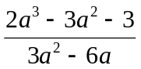 | 1
(v)  - x = 1  x = 1.33  x = 1.33  x = 1.35 | 1
(vi)  - P′ (2) = 0 and 2 - 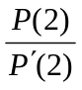 not defined | 1

Sample Answer:

i) xy = -3 ∴ y = 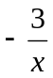

y = x² – 3x ∴ x² – 3x = → x³ – 3x² = -3 ∴ x³ – 3x² + 3 = 0

- P (1) = +1 (< 0), P (2) = -1 (< 0)

Since P (1) and P (2) have opposite signs and since P (x) is continuous P (x) = 0
has a solution x = such that 1 < < 2

iii) P (1.5) = -0.375 (< 0) ∴ 1 < < 1.5

= 1 correct to the nearest whole number

iv) x = a 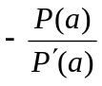 = a 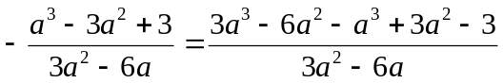
=

v) x = 1 → x = 1.33

x = 1.33 → x = 1.35

- If x = 2 then P′ (2) = 0 and 2 is not defined.

Parramatta Diocese
Catholic Education Office

2001 HSC
Trial Paper

Mathematics

Mathematics

HSC Trial Paper Mapping Grid

Question | Marks | Content | Syllabus  Outcomes | Targeted  performance  bands
1 | 12 | Future Trig  Angle bet 2 lines | PE.2, PE.6  PE.2, PE.6 | E2 – E3  E2 – E3
2 | 9 | Other in equalities  Int/ext div  Polynomials | PE.3  PE.2, PE.6  PE.3 | E2 – E3  E2 – E3  E2 – E3
3 | 15 | Max/ min  Integration | H4, H5  H5, H8 (area) | E3 – E4  E3 – E4
4 | 12 | Induction  Polynominals | HE.2  HE.7 | E3 – E4  E3 – E4

